Installation of Teams

- If you have a school computer, the icon is located on the desktop, or use the « My Web Applications » button.
If you are on a home computer, you must connect to O365 using the Board web site (www.csdcab.on.ca).
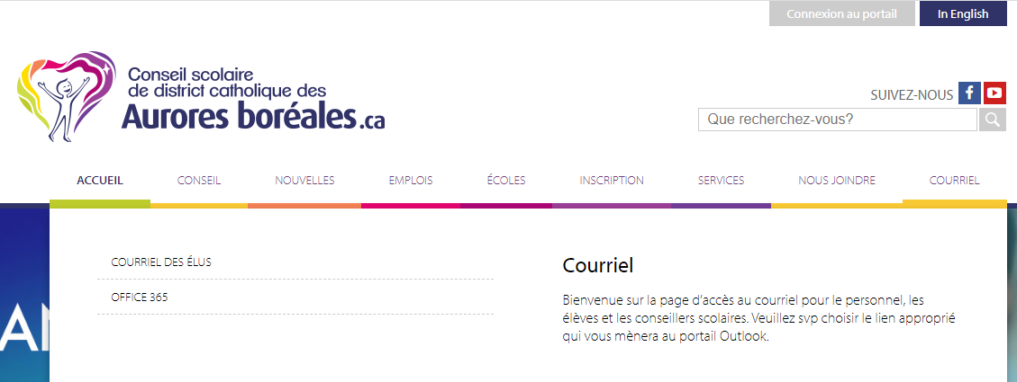
In order to sign in, the student must use his or her school email address and password.
Once connected to O365, you will be redirected to the following screen and will be able to click on the Teams icon:
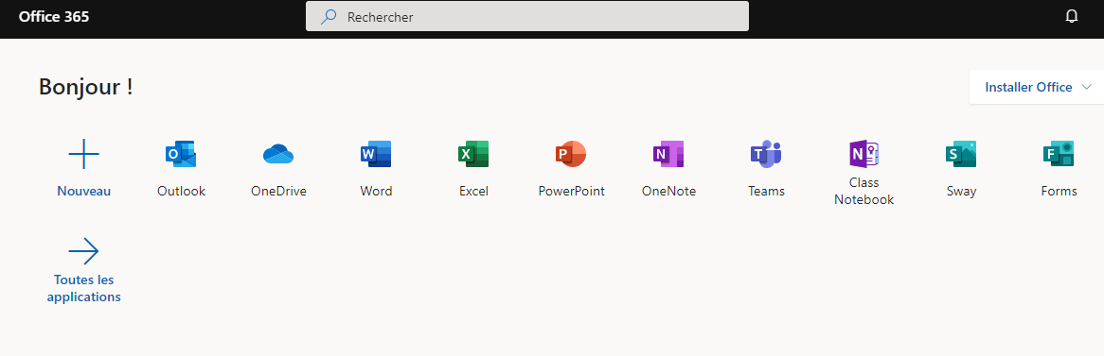
- If you do not see the icon, click on All applications.

- Open Teams by clicking on the following icon:

- You should download Teams on your computer as the online application does not have all the options : click the bottom left icon « Download application ».
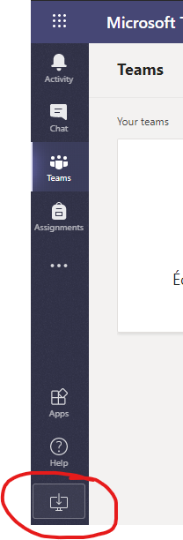

- Install the application. Teams is now installed on your computer.
- The license also allows the installation of the application on your smart phone, Iphone, Ipad, Android

Instructional videos (French):
Trouver et installer Teams : https://youtu.be/4GcqFRtf3AI
Se connecter à une réunion depuis un mobile : https://youtu.be/dIiQ7DG4eI4

